Instructor Individual Feedback
In this your second course project assignment, you were asked to develop a five to seven page Word document that 1) determined which assessment approach for future markets you will pursue: diffusion and adoption, exploration and learning and triangulation for insights, justifying the adoption of your selected emerging technology using your market assessment framework, 2) developed an attribute matrix for your products or services, 3) identified at least two possible market niches or segments, showing them on the graphs, then qualifying these niches or segments with respect to the two product or service attributes you selected for your project, 4) analyzed how the emerging technology you chose could be used to derive a competitive advantage given the product attributes, technology constraints, and market niches you identified, and finally 5) described the forces in the external environment that are most likely to shape your organization's commercialization strategy for its products or services. Without question, much was expected. Toward these goals, you did a good job establishing what I consider to be a very good continuation of your Week One efforts. Once again, your assumptions, assertions, and recommendations seemed on target. I look forward to watching this effort evolve during the upcoming weeks. Further, you exceeded the minimum deliverable length for this assignment. Thanks again for another good effort; your course efforts are coming along nicely!

Managing Emerging Technology in Health Care Telemedicine
The P&S Market Research has projected that the global telemedicine market is to propagate to a size of $48.8 billion dollars by 2023 (Prescient & Strategic Intelligence, 2018). The Substantial development in the telemedicine is due to the increasing amount of health care cost, increasing numbers of chronic and lifestyle diseases and higher emergency room visits and readmission rated continue to rise. Telemedicine benefits patients and facilities by reducing the number of emergency room visits and hospital stays thus increasing market development for this emerging technology. Decreasing the cost for health care for patients, providing more efficient care in a timely manner, causes the demand for market development in telemedicine market as well.
My recommendation for which assessment approach for future markets in telemedicine I would choose exploration and learning. Telemedicine is not a new technology, but definitely emerging in the technology world, allowing for the ability to the facilities to reach out to others to see how this technology has been performing in the market. With this assessment approach, we will be able to gain the knowledge of what worked well with rolling out telemedicine and helped increase adaptability. However, it also allows for us to gain the knowledge of the pitfalls they had rolled it out as well as issues they are or have experienced with patient concerns as well as staff concerns so hopeful the facility can avoid the same pitfalls. The company will be able to take the time to learn about the market from other facilities, but also from the Telemedicine Resource Center for their geographical area. The Southeastern Telehealth resource center has a wide-range of telehealth knowledge and have reviewed and successfully implemented at Georgia Telehealth and its partner sites (Southeastern Telehealth Resource Center, n.d.). This approach works best for us since the accessible resources and facilities already using the technology is abundant giving us plenty of room to explore and learn. My market assessment framework was to observe which customer base received most advantages of telemedicine, which specialty services are needed the most for market growth, what is the actual cost savings can we expect in our facility as well as the patients who participate will we be able to use this for marketing this for our facility. What is the best way to market to get the largest population's attention? However, the biggest barrier is a security and privacy, especially dealing with patient medical information so we would look at how secure has this process been, what are some functions that can be put in place to protect our patients as well as the facility.
Market Assessment

Attribution Matrix
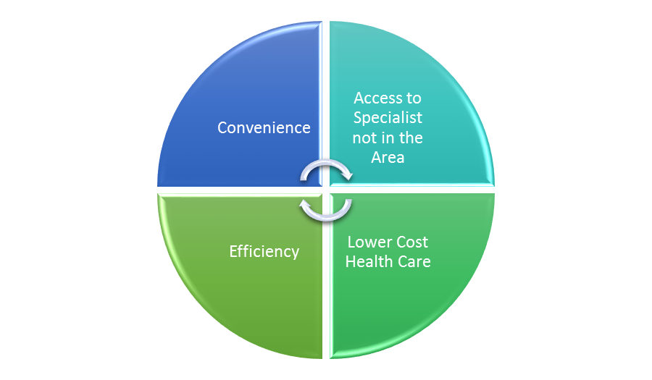
A basic attribute Telemedicine provides is more efficient care to patients, there was a study done on homebound patients who had at least two hospital admissions during the previous year it was found that the admissions decreased from 2.6 admissions per patient to 1.1 admissions per patient and the emergency room visits dropped by 2.1 visits as well (Mercer, 2018). Telemedicine can eliminate the need for excessive health care resources, allowing for the provider to intervene at a faster rate and address diseases as they arise instead of when the patient can come to the office. With fewer resources involved, fewer visits and shorter stays required it brings down the cost of health care. An energizer attributes to telemedicine is the convenience of not having to leave home to be treated by a medical professional allowing chronic disease patients, such as diabetes, COPD, heart failure to be better monitored and treated. Because telemedicine is more efficient, convenient and costs less for the patient, more patient is likely to obtain the medical care they need instead of waiting until it’s an emergency room visit and readmitted due to not being compliant with their treatment.
Two important attributes to the continued growth in telemedicine are the ability to provide the patient with more convenient care without having to worry about traveling to the facility to wait in the waiting room for hours as well as lowering the cost of healthcare with fewer visits and better management of the patient’s chronic medical conditions. Barriers I have chosen to demonstrate in my graph, are the patient being incorrectly diagnosed due to not having hands-on care. The Journal of the American Medical Association Dermatology studied how truthful skin disease was being diagnosed and treated, the conclusion was 62 encounters from 16 diverse facilities' websites, found that key dermatology diagnoses were frequently overlooked and in some of the cases the patients were prescribed treatment they didn’t need (Paulson & Nace Attorneys at law, n.d.). The second barrier you will see noted on my graph is security and patient privacy, data breaches happen on a regular basis, so keeping our patient’s information secure and making sure that the patient is sending his/her information to the correct individual is another barrier that needs to be noted in telemedicine. The final barrier you see on the graph is compassionate care, telling the patient they have a common cold or psoriasis is different than telling a patient they have an incurable disease, compassion needs to be understood just as if the patient was in the office.

Privacy/Security
Barrier
Compassionate Care

Incorrect Diagnoses

CONVENIENCE
Behavioral Health

Correctional Healthcare

LOWER COST HEALTHCARE
Organizations and facilities looking to the emerging telemedicine world the market niches that should be watched is a behavioral health with a therapist or physician conversations with the patients. Patients do not have to physically go to the psychologist's office, which may seem petty, but going to a psychologist office in a small town leads to everyone talking if they see you there. With telemedicine, it offers a more discrete way to have your visit, but still can get appropriate treatment. The Veterans Administration, in utilizing the technology to help cope with soldiers returning home from war zones as per the American Telemedicine Association (Baum, 2012). Soldiers receiving appropriate treatment and being able to feel like they have someone they can reach out to be important for healing and them going to a psychologist office will not happen like it should so it’s great this technology brings the car to the heroes. The other market niche is a correctional health care. Prisons cost for transporting patients to health care facilities can be high and cause security issues. Care can be administered via telemedicine vs having to transport to a hospital that’s not set up for the security measures like prisons when treating a population that’s as receptive to in-person care. I can tell from experience working in hospital settings who receive prison and jail inmates have been proven a dangerous task with the right inmate, if care could have been provided to them in their secure environment it would have been a better option.
Currently, I am not seeing where there is no competitive advantage to telemedicine, it currently is at the top of its market and even with the constraints with the correct measures in place and the ability to show the same compassion, you show in the office the attributes out weight them. The market niches that I identified benefit greatly from telemedicine technology a lot of times behavioral health issues are shamed upon and people do not want to seek treatment in an office because of the stigmatisms behind having trouble with issues, even though millions suffer from a psychological issues people don’t want to reach out due to this, telemedicine offers the ultimate privacy of your own home. The forces that are pushing this is the decline in providers by 2025 (Sherling MD & Sherling MD, MBA, 2017), this is already showing to be an issue with how long it takes to get put on a providers schedule so the need for a more effective healthcare visit is needed. More so the growth of chronic and lifestyle diseases that continue to grow out of control such as diabetes, high blood pressure, COPD, these diseases that need better management of care to help patients be more compliant with their treatment, preventing emergency room visits or repeat admissions due to the patient being non-compliant to treatment.
Telemedicine is a technology of its time in the medical world that is growing rapidly and can help so many it can offer health care to those who would not normally reach out or those who are unable to obtain medical care due to their situation such as being incarcerated or being afraid to seek help due to the mentality of physiological issues. Every emerging technology has barriers, however with the correct components put into place and the appropriate care telemedicine can be the future way of us is viewing future health care visits and needs.

References
ADD ON DATA. (2017, September 12). Retrieved from 5 Ways telemedicine benefits providers and patients: https://www.addondata.com/2017/09/5-ways-telemedicine-benefits-providers-and-patients/
American Telemedicine Association. (n.d.). Retrieved from American Telemedicine Association: http://www.americantelemed.org/home
Baum, S. (2012, May 23). Health IT. Retrieved from 6 Niche Margets for Telemedicine: https://medcitynews.com/2012/05/6-niche-markets-for-telemedicine/
CDC. (2018, August 7). Retrieved from Health and Economic Cost of Chronic Disease: https://www.cdc.gov/chronicdisease/about/costs/index.htm
Eysenbach, G. (2016, May 18). NCBI. Retrieved from Acceptability, Feasibility, and cost of telemedicine: https://www.ncbi.nlm.nih.gov/pmc/articles/PMC4906238/
Fields, M. (Ed.). (n.d.). NCBI. Retrieved August 23, 2018, from https://www.ncbi.nlm.nih.gov/books/NBK45445/
Mercer, L. (2018, March 18). Improving Healthcare Efficiency With Telehealth. Retrieved from Health Recovery Solution: https://www.healthrecoverysolutions.com/blog/improving-healthcare-efficiency-with-telehealth
Paulson & Nace Attorneys at law. (n.d.). Retrieved from https://www.paulsonandnace.com/telemedicine-misdiagnosis-medical-malpractice/
Prescient & Strategic Intelligence. (2018, June). Retrieved from https://www.psmarketresearch.com/press-release/global-telemedicine-market
Sherling MD, D., & Sherling MD, MBA, M. (2017, June 19). American Jornal of Accountable care. Retrieved from The Promises and Pittfalls of Telmedicine: https://www.ajmc.com/journals/ajac/2017/2017-vol5-n2/the-promises-and-pitfalls-of-telemedicine
Southeastern Telehealth Resource Center. (n.d.). Retrieved from http://www.setrc.us/

